Not as Simple as it Looks: Led Outdoor Activities are Complex Sociotechnical Systems
Tony Carden¹, Natassia Goode¹ and Paul M. Salmon¹,
¹Centre for Human Factors and Sociotechnical Systems, University of the Sunshine Coast, Sippy Downs, Queensland, Australia
tony.carden@research.usc.edu.au,
Abstract
Recent research is providing valuable insights into safety by applying sociotechnical systems (STS) theory to led outdoor activity (LOA) work systems. The LOA domain involves provision of supervised or instructed activities such as kayaking, rock climbing and camping. Despite these successful applications, questions persist regarding the extent to which STS theory and methods are applicable given the apparently simplistic nature of the domain. This paper seeks to evaluate the validity of systems theoretic approaches by comparing a typical LOA work system with established characteristics of STS and complex systems. Features of the LOA work system are compared with established characteristics of complexity, then considered in relation to STS theory principles. The findings show that this system of work is indeed both complex and sociotechnical. It is concluded that application of STS theory and methods is both appropriate and required to attain improvements in practice and safety in LOA work systems.
Keywords: Adventure activities · Adventure education · Complexity · Outdoor activities · Outdoor education · Outdoor recreation · Sociotechnical systems
Introduction
Led outdoor activities (LOA; defined as facilitated or instructed activities within outdoor education and recreation settings, (Salmon, Williamson, Lenné, Mitsopoulos-Rubens, & Rudin-Brown, 2010)) represent an important form of active recreation, and include activities such as hiking (also known as bushwalking, trekking or tramping), paddle sports (including rafting, canoeing and kayaking), roped activities (including abseiling, rock climbing and challenge ropes courses) and snow sports (such as skiing, snowboarding and snow shoeing). Programs of one or more of these activities are commonly run by schools, community clubs or organisations such as Scouts, and private organisations that offer their services to the public. The aims of such programs can be educational, recreational or therapeutic (Goode, Finch, Cassell, Lenné, & Salmon, 2014). In educational and therapeutic applications, the activities are often used as metaphors for participants’ life experiences and thereby as a catalyst for learning or personal development (e.g. Priest & Gass, 2005, p.217).
The led outdoor activity sector experiences adverse events that can cause injury, and in the worst cases, multiple fatalities (e.g. Brookes, 2011). Examples of recent major incidents in this sector include the Mangatepopo gorge incident in which six year 12 students and their teacher drowned during a gorge walking activity in the Tongariro National Park, New Zealand (Devonport, 2010) and the death of a year 7 student in a pond whilst on school camp in Toolangi, Victoria (White, 2014). A large body of research has responded to these events by applying a systems thinking approach in an attempt to understand and prevent injury during led outdoor activities. For example, systems analyses of fatal incidents have identified multiple contributory factors related to various different actors, equipment, processes, and organisations (Salmon et al., 2010; Salmon, Cornelissen, & Trotter, 2012; Salmon et al., 2016). Further, research examining more common injury incidents has revealed similar findings, showing that these also involve multiple contributory factors (e.g. Salmon, Goode, Lenne, Finch, & Cassell, 2014; Salmon et al., 2016). Following these applications, the LOA sector in Australia has developed an industry-wide incident reporting system underpinned by a systems thinking framework (UPLOADS; Goode, Salmon, Lenné, & Finch, 2015 ; Salmon et al., 2016). The systems thinking approach is now firmly embedded in the LOA sector’s approach to injury prevention.
STS theory arose in the context of industrial work settings where the introduction of new technologies was found to be disrupting social foundations of work with adverse effects on productivity (Eason, 2014; Trist & Bamforth, 1951). It developed further in work settings where the introduction of computer technology became increasingly prominent. Previously stable, tightly constrained systems became more difficult to understand and modify with traditional methods as the introduction of new technologies drove change toward less stability and greater variability of constraints (Vicente & Christoffersen, 2006).
Underpinned by complexity theory and STS theory, the systems thinking approach has traditionally been applied in high-risk safety critical systems such as transportation and process control. Part of the justification for such applications is that these systems are highly complex and dynamic, comprising multiple interacting human and technological components. Likewise, recent applications of systems thinking in the led outdoor context are based on the notion that led outdoor activity systems are complex, dynamic systems and exhibit many of the characteristics that are discussed in relation to complexity and sociotechnical systems (Salmon et al., 2012; 2014). For some who work in the LOA domain, however, this premise seems counter-intuitive, given the apparent simplicity of their work. Indeed, trekking in a remote wilderness or paddling with a small group along an unspoiled coastline conjure images of a simple life, far removed from the busy-ness of modern, urban living. These examples and many other experiences available for people to spend time in nature do afford a simplification of daily life. Daily routines, ubiquitous technology, noise and pollution can be left behind for a while. The experience afforded to participants by this work domain can indeed be viewed as simple. Upon reviewing accident analysis methods developed and used within the LOA sector, Salmon et al. (2009) concluded that systems thinking, which could indicate recognition of system complexity, was not evident in the methods reviewed. This suggested a fundamental inadequacy in the prevailing understanding of the nature of the LOA system; however, this is only a fundamental flaw if LOA systems display the characteristics of complex sociotechnical systems.
Complex, non-linear systems can be characterised by the phrase. “the system is greater than the sum of its parts”. In contrast, linear, deterministic systems can be characterised by the phrase “the system is the sum of its parts”. The former can be best understood by considering all system entities and their interactions together in a process of synthesis, whereas the latter can be satisfactorily understood by decomposing the system into its component parts and subjecting them to analysis (Cilliers, 1998).
Differences between the theoretical and analytical approaches required for both perspectives are perhaps best demonstrated through models of accident causation. These have evolved through several distinct stages (Toft, Dell, Klockner, & Hutton, 2012). From the 1930s, simple sequential linear models, beginning with Heinrich’s ‘Domino theory’ (as cited in Toft et al., 2012, p. 4), posited that accidents were a result of a linear sequence of factors. Accidents were seen to be primarily a result of human error or mechanical failure in close proximity to the accident. In the 1960s, more sophisticated complex linear models began to emerge (Toft et al., 2012, p. 7). Unlike earlier approaches, these models began to account for multiple events in a sequential causal path. Furthermore, they began to account for causal factors at a greater distance in time and space from an accident. Like their predecessors, however, these second generation models assumed and sought to identify a ‘root cause’. From the 1980s, complex non-linear models began to emerge (e.g. Rasmussen’s (1997) Risk Management Framework; STAMP (Leveson, 2004); FRAM (Hollnagel, 2012)) which could account, not only for multiple and non-local causes of accidents, but also for emergent causes which arose as a result of interactions between system elements. This third generation of models offers a more accurate means of understanding complex sociotechnical domains than its predecessors.
It should be noted that the literature on safety and systems theory is inconsistent in the use of terms to describe different system types. The term ‘complex’ in particular has been used to refer both to linear and non-linear systems. The present analysis will follow Kurtz and Snowden (2003) in reserving the term ‘complex’ to refer to complex, dynamic, non-linear systems. It is important to distinguish them from linear systems which may have very many elements and are thereby complicated, but do not exhibit the characteristics of complex systems.
Accurately identifying whether or not the LOA work system is complex by analyzing system characteristics has significant implications for how such systems are regulated, managed, supervised and operated. Differences between the nature of complex and non-complex systems mean that misunderstanding the nature of the system will give rise to completely inappropriate regulatory, management and accident prevention strategies, leading to critical safety failures along with structural incapacity to optimise the productive output of the system. Therefore, this study aims to determine whether the LOA work system is a complex STS and if so, to discuss what implications this may have for practice and future research in the LOA domain.
The following section presents a brief overview of the two competing paradigms in LOA research, one that considers the domain as a complex sociotechnical system and another that supports a linear, deterministic view.
Competing paradigms in LOA research
A growing body of research has considered the LOA work domain as a sociotechnical system. This systems-thinking approach has been applied to a number of dimensions of the LOA work system, as illustrated by the following three examples.
First, in their study of accident causation Salmon, Cornelissen and Trotter (2012) applied a selection of systems-based methods to the analysis of the Mangatepopo Gorge incident (Devonport, 2010). This study showed that systems-based methods support the identification of causal factors that occur in close proximity to an accident along with factors at higher system levels and those that result from interactions between entities at different system levels (Salmon et al., 2012, p. 1163). This has led to the development of a model of the LOA work domain that includes the regulatory and legislative levels, along with management, supervisory, operational and physical levels. This model acts as a framework, underpinning an incident reporting taxonomy and database (UPLOADS; Salmon et al., 2016)
Secondly, the sociotechnical systems paradigm has been used to support the evaluation of risk assessment practices in outdoor education programs (Dallat, Salmon, & Goode, 2015). This study found that commonly used risk assessment methods are inadequate for identifying causal factors at higher system levels. Development of a systems-based risk assessment method was recommended.
Finally, the role of improvisation among outdoor leaders in supporting safety has been examined using sociotechnical systems-based analysis methods (Trotter, Salmon, & Lenné, 2013). This research identified ways in which outdoor leaders’ decisions when improvising to support safety were influenced by factors across multiple system levels.
Before these applications, other research in the LOA domain had modelled the system of work in a more deterministic, linear way. The following examples demonstrate this approach.
A number of accident causation models have been developed for led outdoor activities (Salmon et al., 2009). Of these, both Brackenreg’s (1999) Accident Potential Model and Meyer’s (1979) Principal Causes model, from which it is adapted, identify causal factors in the immediate proximity of an accident. Hazards are seen to arise from activity leaders, participants, equipment, the environment, or as a result of interactions between any of these system entities. Davidson’s (2007) Root Cause model accommodates identification of a broader range of causal factors by noting the possibility of them arising in safety management systems and senior management. All three of these models account for multiple causes of accidents and the interaction of system entities, however they offer no guidance for analysis of those interactions nor for the development of associated countermeasures. None of these models account for causal factors that may occur at higher system levels such as the regulatory or legislative. They can therefore be seen to belong to the second generation of accident causation models identified by Toft et al. (2012).
The ChANGeS Framework is a contemporary model which seeks to identify and describe the factors that contribute to the achievement of beneficial outcomes of led outdoor activity programs (Williams, 2012). The model identifies five common components of outdoor programs (challenge, activity, nature, guided experience and social milieu) in order to rate the extent of the presence of these components. The prominence of each component in a program is assessed and an ordinal rating is assigned. This seems to imply that program effectiveness is a function of the strength of individual components. Moreover, the method appears to suggest that the beneficial potential of a LOA program can then be expressed as an aggregate sum of these component ratings. No consideration is given to the interactions between these or other program components, nor to other entities in the broader system. Whilst linear, deterministic systems can be understood as a sum of their parts, complex, non-linear systems cannot (Cilliers, 1998).
Similarly, the extensive literature on outdoor leadership seems to assume that leadership is a product of individual ability, rather than a supportive system (e.g. Crosby & Benseman, 2003, p. 43; Martin, Cashel, Wagstaff, & Breunig, 2006, pp. 56-57; Priest & Gass, 2005). This has significant consequences both for risk management and for the achievement of beneficial program aims. For example, although novel developments of leadership attributes and styles are explored by Smith and Penney (2010), little consideration is given to the context in which leadership occurs, much less to the effect of that context on leadership itself. This appears to follow an orthodoxy in the LOA domain, that leadership is determined entirely by the attributes or competencies of the leader (e.g. Priest & Gass, 2005, p. 3). This view stands in contrast to contemporary models of leadership from other domains which see it as always embedded within and interdependent with a broader system (e.g. Lichtenstein & Plowman, 2009).
If the LOA system is in fact complex and non-linear, rather than deterministic and linear, research that seeks to support all of the dimensions of work in the domain, including safety, effective program design and staff training, will benefit from adoption of the systems thinking paradigm.
This article therefore sets out to answer the question of whether LOA systems are complex and sociotechnical in nature. To achieve this, using a case study of a three-day trek we examine the characteristics of LOA systems and compare them to the core characteristics of complexity theory (Cilliers, 1998), sociotechnical systems theory (Trist, 1981), and contemporary models of accident causation (Rasmussen, 1997). The aim is to determine whether led outdoor activity work systems are indeed complex in nature, and thus whether the growing body of research that adopts a systems approach is warranted.
What criteria can determine whether a system is Sociotechnical and Complex?
Before outlining the case study, it is first worth defining what it is that makes a system sociotechnical and complex in nature. Sociotechnical systems are defined widely in Human Factors and Cognitive Ergonomics literature as systems of work that comprise social subsystems (people) interacting with technical subsystems (devices, interfaces and work practices) in pursuit of a common goal (e.g. Walker, Stanton, Salmon, & Jenkins, 2008). Klein (2014) has emphasised that the social and the technical are interdependent aspects of the same system in order to avoid any tendency to view either is self-contained. This is important due to the need for the social and technical aspects of a sociotechnical system to be developed in conjunction with each other, rather than separately (Jenkins, Stanton, Salmon, & Walker, 2009; Trist, 1981).
Whether sociotechnical or not, criteria for identifying a complex system are not necessarily obvious or straightforward. Furthermore, a complex system is not the same as a complicated system. Even though it may have many components, a system is not complex if the whole system state and the state of the entities of which the system is composed is reliably predictable. This depends on all system entities and the relationships between them being amenable to complete description. Future states of these linear, deterministic systems can be reliably predicted via accurate analysis of any present state (Cilliers, 1998). Components of such systems do not change over time, they do not develop new interactions with other system components or with their environment. The output of such systems generally relies on all system entities continuing to operate and interact in the manner in which the system is initially configured. Such systems may be simple (for example a pendulum) or complicated (for example, a jumbo jet) but they are not complex.
Scholars in the domains of general systems theory and sociotechnical systems theory have identified a wide range of characteristics that are indicative of complexity (e.g. Cilliers, 1998; Skyttner, 2005; Vicente, 1999; von Bertalanffy, 1975). Cilliers’ (1998, pp. 15-19) characteristics have been chosen for this study as they appear to incorporate criteria identified by earlier scholars and to be generic enough to suit application across a broad range of work system types. According to Cillers, complex systems exhibit the following characteristics: a large number of elements; dynamic interactions between elements; elements interact with multiple other elements, interactions between elements are non-linear (small causes lead to large effects & vice versa), information is received primarily from immediate neighbours; recurrent loops in interactions; complex systems are open systems (it is difficult to define the border and the system interacts with its environment); requires constant flow of energy to maintain system organization; a complex system’s past is co-responsible for its present behavior; and each element in the system is ignorant of the behaviour of the system as a whole. These characteristics were used as criteria in the case study analysis.
Methods and Sources
A case study approach was adopted whereby the work system that supports a typical LOA program was considered. First, a logistically simple example of a LOA system was analysed to determine the extent to which it aligns with Cilliers’ characteristics of complexity. Secondly, the system model was compared with five STS design principles which were selected on the basis of their prominence and frequency of appearance in a review of STS literature. The design principles were joint optimization (Jenkins et al., 2009; Trist, 1981), vertical integration (Rasmussen, 1997; Salmon et al., 2012), flexibility (user finishes the design) (Clegg, 2000; Jenkins et al., 2012), simplicity (minimal critical specification) (Cherns, 1987; Clegg, 2000), and problems can be controlled at the source (Cherns, 1987; Clegg, 2000).
A subject matter expert (SME) who has over ten years’ experience leading and managing similar programs for an Australian organization was asked to identify and describe a typical and logistically simple LOA. Actors, objects and processes (all considered as ‘entities’ in this analysis) involved in this system were identified from interviews with the SME. The system entities identified for the three-day trek were then allocated to levels of the UPLOADS framework (Goode, Salmon, Taylor, Lenné, & Finch, 2016; Salmon et al., 2016), a representation of the led outdoor activity work domain based on Rasmussen’s (1997) risk management framework. Rasmussen developed his framework to model risk control structures across different social levels in work systems. This allowed a systems view of accident causation whereby causal factors at different system levels could be viewed together and interactions between them identified.
Any system can in principle be decomposed down to ever finer levels of resolution. For example, each raindrop, each tree branch, each hair on the head of a participant could be considered as an individual element in this system. The focus of the present analysis was system effects on participants, both beneficial, intended outcomes and undesirable accidents. Therefore, the level of resolution is that of individual participants and the other people, objects and processes that interact with them within the system boundary.
The system levels represented by the UPLOADS Framework are shown in figure 1. Each system level can be viewed as a subsystem or as an aspect of the whole work domain.
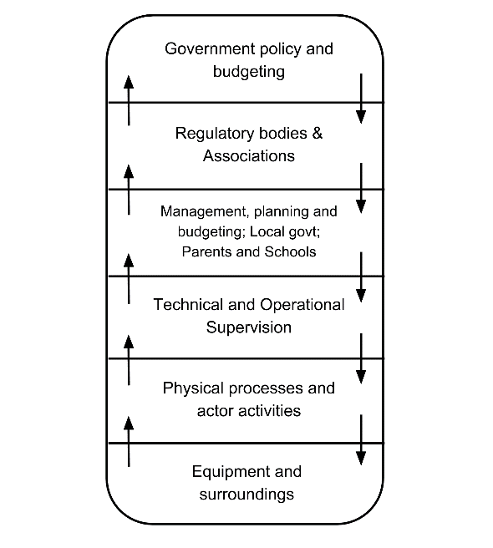
Figure 1: The UPLOADS framework

Relationships between entities and their placement in the domain hierarchy were identified through discussion between the analyst and the SME. A sociotechnical system map was developed showing the main entities in the system and some examples of temporary, emergent entities. A persistent entity exists in this system for the duration of the system’s life; that is, the persistent entities exist throughout the entire activity from commencement to completion of the program. Examples include the leader, the terrain and land use restrictions. Temporary or transient entities may emerge from interactions between other entities in response to both planned and unplanned situations. For example, a cooking team is a transient entity with its own unique properties which may form to prepare an evening meal. A temporary rain shelter is an entity that may be spontaneously built in response to an unexpected downpour. The resulting sociotechnical system map was then validated by a second SME with a similar background to the first.
Case Study
The three-day trek is a walking journey for a single group of 12 new members of a community bushwalking club and one experienced leader in a semi-remote area in south eastern Australia in October. The goal of the activity is to help participants develop the practical skills of self-contained outdoor living, help group members get to know each other and to create opportunities for a deeper connection with nature. The trek is planned to take three-days and the group are to camp each night, using tents and other equipment carried with them in backpacks. The trek route begins near a carpark and then moves away from roads and other artificial structures. Cell phone reception is only sporadically available in the area.
Sources of drinking water are available at both planned overnight campsites. Each participant carries a backpack containing their sleeping bag, food, water, clothing and personal equipment (e.g. toiletries, medication, mobile phone, GPS device). Group equipment such as tarpaulins, ropes, a shovel and cooking equipment is distributed among group members to be carried in their backpacks. In addition, the leader carries a first aid kit, medical information for all group members, a printed weather forecast, a map, a compass, route notes, a mobile phone and a UHF radio. The trek route is planned to take the group across two mountain ranges and to conclude at a carpark about 40 km from the starting point. Terrain on the planned route includes flat and undulating trails through valleys and plains and steep rocky sections at higher elevations. Flora and fauna in the area include tree ferns, spiky shrubs, eucalyptus trees, kangaroos, wombats, possums, venomous snakes and numerous insects. Weather in this area during October typically incudes a temperature range of 4°C - 28°C with the possibility of strong winds and heavy rain.
The system in which a trek like this takes place includes several classes of interacting entities or elements. Actors are entities in this system that include participants, leaders and supervisors. Physical objects are entities such as items of camping equipment, route notes and trees. Cognitive objects are conceptual entities including trip objectives, activity standards and learning outcomes. Processes are entities such as compliance checking and route planning.
Each entity is an element within the system and interacts with other elements and is represented as a node on the system map in Figure 2. In order to understand the complexity of the system, the nature, number and scope of these entities is now considered, along with their relationships with each other.
Evaluation: is the LOA work system sociotechnical and complex?
The system map in Figure 2 shows that this led outdoor activity program does indeed constitute a sociotechnical system according to Klein’s (2014, p. 138) definition, which identifies interdependence between social and technical system aspects as the defining characteristic of a sociotechnical system. Figure 2 shows social elements and subsystems (for example, leaders, participants and group), and technical elements and subsystems (for example, group equipment; map, compass and route notes; standard operating procedures), that interact with each other and with an external environment. A representative example of the interdependence evident in these interactions is that a navigator is dependent on a compass to determine direction and location, and the compass is dependent on its correct use by a navigator to fulfil its purpose. The interaction between social and technical system entities is undertaken to achieve the program’s stated goals.
There are a number of difficulties associated with any attempt to analyse the characteristics of a domain of work. Two challenges are particularly relevant here. The first is deciding the system boundaries. The second is deciding on the level of granularity or resolution at which the system under examination should be viewed (Naikar, 2013). This decision must be carefully made by the analyst based on the purpose of the analysis. In this case, the purpose is to understand ways in which system entities can act and interact to compromise safety. Both the system boundary and the resolution level were chosen accordingly.
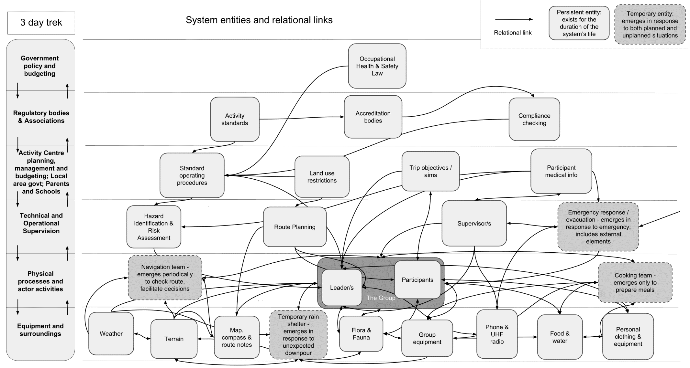

Figure 2: System map for a 3-day trek

Characteristics of complexity evident in the case study
In Table 1, the led outdoor activity system characteristics are examined against Cilliers’ characteristics of complex systems (Cilliers, 1998).

Table 1: Examination of three-day trek led outdoor activity system against complexity criteria.

Characteristics of Complex Systems | Examples of characteristic in three-day trek
Large number of elements | The nodes shown in figure 2 represent a number of entities: participants, group equipment, personal clothing & equipment are three examples of nodes that represent several elements. Importantly, these elements include human, environmental, technological, and non-technological artefacts.
Dynamic interactions between elements | There are many dynamic interactions between elements. For example, the leader may check participants’ navigation skills and, if required, teach how to navigate with map and compass; all group members interact dynamically with the weather, the terrain, flora and fauna and equipment. For example, participants may put on raincoats if it rains, apply insect repellent if mosquitos are biting or set up a rope to assist in crossing a fast-flowing stream.
Elements interact with multiple other elements | Most elements shown in figure 2 interact with multiple other elements. For example, group members interact with many other system elements; an evening meal can be produced for the group by one or several group members interacting with cooking equipment, the leader, ingredients etc.; a navigation decision can be made quickly based on prior experience or multiple options can be considered; a temporary rain shelter can be constructed by many or few participants from many or few components.
Interactions between elements are non-linear: small causes => large effects & vice versa | A few missing words in a weather report can lead to a multiple fatality incident (e.g. as in the Mangatepopo Gorge incident, see Salmon et al., 2012); a chance close encounter with a soaring eagle on a mountain peak can trigger an epiphany.
Information is received primarily from immediate neighbours | Aside from phone and radio communications the leader may have, most information enters the system from local sources.
Recurrent loops in interactions | Cyclic processes of camping, cooking, packing and unpacking constitute recurrent loops; in outdoor education programs, learning occurs during the trip through recurrent loops of planning, experience and reflection.
Complex systems are open systems: it is difficult to define the border and the system interacts with its environment | Elements in the physical environment such as rocks, trees, trail declines and inclines are continuously entering and exiting the boundary of this system as the group travels; the system continuously interacts dynamically with the physical environment, including weather, beyond the system boundary at any given moment; temporary entities emerge within the system boundary and then dissolve.
Requires constant flow of energy to maintain system organisation | Navigation, group discussion, leadership decisions and action all represent energy flows that maintain system organisation. If any one component stops the overall activity cannot proceed effectively.
A complex system’s past is co-responsible for its present behaviour | Pre-trip preparation will determine resources available during the trip which will, in turn, constrain options available; interactions between participants may influence their relationship and the nature and outcome of subsequent interactions; physical features in the landscape where a program takes place long precede the program and shape the nature of the activity and procedures adopted.
Each element in the system is ignorant of the behaviour of the system as a whole | The activity leader would be able to describe all of the parts and behaviours within a hiking shoe yet would not be able to describe all of the parts, interactions and behaviours that make up the hiking activity system.

As shown in Table 1, the simplistic three-day trek led outdoor activity system can be viewed as displaying all of Cilliers’ characteristics of complexity. Next, the led outdoor activity system is compared with STS principles.
Sociotechnical Systems Principles
Whilst a number of sociotechnical systems principles pertain to specific work systems and may not be relevant to analysis of a hypothetical system, the model developed here does allow some conclusions to be drawn about the extent to which this type of system may intrinsically align with STS principles. Table 2 includes a core set of STS principles which are observed in the work system under analysis, their sources in the literature and observations on their relevance to the LOA work system illustrated in figure 1.

Table 2: Comparison of LOA system model with STS principles.

STS principle | Source / description | Relevance to LOA work system
Joint optimisation | The social and the technical aspects of work systems should be optimised in conjunction with each other. (Jenkins et al., 2009; Trist, 1981) | The emergent ‘Cooking Team’, shown at the right of figure 2 is an example where techniques and tools must align with users’ needs, skills, experience and the relevant rules and goals.
Vertical integration | Performance depends on effective flow of information up and down the levels of the system. (Rasmussen, 1997; Salmon et al., 2012) | The nature of led outdoor activity work system is such that leaders and participants are working in isolation from supervisory and control mechanisms. This means that system performance is critically dependent on effective flow of information about rules and goals from the upper levels to the lower and about work performance from the lower to the upper.
Flexibility (user finishes the design) | “…one should not over-specify how a system will work (minimal critical specification). Whilst the ends should be agreed and specified, the means should not.” (Clegg, 2000) | The open nature of the work system and its uncertainty mean that prescriptive practices and procedures are unlikely to support effective system performance. Goal based controls which allow users (leaders and participants) to ‘finish the design’ (Read, Salmon, Lenne, & Stanton, 2015) are more likely to support the achievement of system goals.
Simplicity (minimal critical specification) | “This … includes a range of more detailed concerns such as ease of use, ease of understanding, and learnability.” (Clegg, 2000) | The multiplicity of known and possible emergent tasks required of leaders mean that system performance will be supported by avoiding over-complication of specific tasks and procedures for leaders, allowing them space to respond effectively to emerging conditions.
Problems can be controlled at source | “…variances (un-programmed events) should be controlled at source…” (Clegg, 2000) | The relative isolation of the locus of work means that emergent problems must be controlled at the source at least initially as external support may not be immediately available.

The led outdoor activity system clearly is ‘sociotechnical’, in that it includes a social aspect (e.g. leader, participants, supervisor, emergency responders) and a technical aspect (e.g. group equipment, personal equipment, standard operating procedures). The characteristics noted in table 1 indicate that this system is complex.
Discussion
The aim of this article was to determine whether led outdoor activity systems are complex and sociotechnical nature. Given the spate of recent systems thinking applications in LOAs (e.g. Goode et al., 2016; Salmon et al., 2016), this line of inquiry represents an important one for practice and research in this area. Therefore, a case study analysis of a three-day trek was undertaken using the UPLOADS framework.
Based on a comparison with accepted characteristics of complexity and sociotechnical systems, the findings suggest that even relatively simplistic LOA systems are indeed complex and sociotechnical in nature. This suggests that, not only are systems thinking applications in this area warranted, they are imperative should the desired outcome be safety and efficiency gains (Salmon et al., 2016). The remainder of this discussion now turns to some important implications for practice and research.
Implications for practice
The dynamic interactions, non-linearity, openness and component ignorance of total system state in complex systems mean that accurate prediction of all future system states is impossible. This presence of uncertainty as an inherent feature of complex systems is of particular significance for planners and managers. It is important to note that each entity identified here, while a subsystem of the LOA system being considered, can be viewed as a system in its own right, composed of its own component entities and subsystems. Some component entities in the LOA system are themselves complex systems (e.g. the human actors, flora and fauna, and weather), while others can properly be viewed as linear, deterministic (and thereby predictable) systems. The presence of complex system components ensures that the overall system is complex in nature at least to the extent that uncertainty will transfer to the larger system from its complex components, by way of their interactions with other system entities. For LOA system designers, this suggests a need to build redundancy into the system in order to support system capacity to self-organise in response to the emergence of unforeseen events (Cilliers, 1998, pp. 21-22).
Management implications
Whilst all of Cilliers’ characteristics of complexity can be seen to have implications for the effective management and operation of complex sociotechnical systems, those that have the greatest effect on possible states of knowledge about the system are of most relevance to system management.
Although it has been described as a characteristic of complex systems (e.g. Jenkins et al., 2009), uncertainty may be more accurately understood as a cognitive state experienced by an observer who may or may not be part of the system. As Storr (2005) identified, this requires actors at all levels of complex sociotechnical systems (e.g. legislators, regulators, managers, supervisors, workers, participants) to contend with four types of system outcomes: predictable and desirable; predictable and undesirable; unpredictable and desirable; unpredictable and undesirable. The pursuit of desirable outcomes in sociotechnical systems of work is usually considered to lie within the realm of productivity while the avoidance of undesirable outcomes prominently includes efforts focused on safety. Figure 3 shows how these categories of management focus interact with system complexity to produce the outcome states noted by Storr, along with his proposed management approaches.
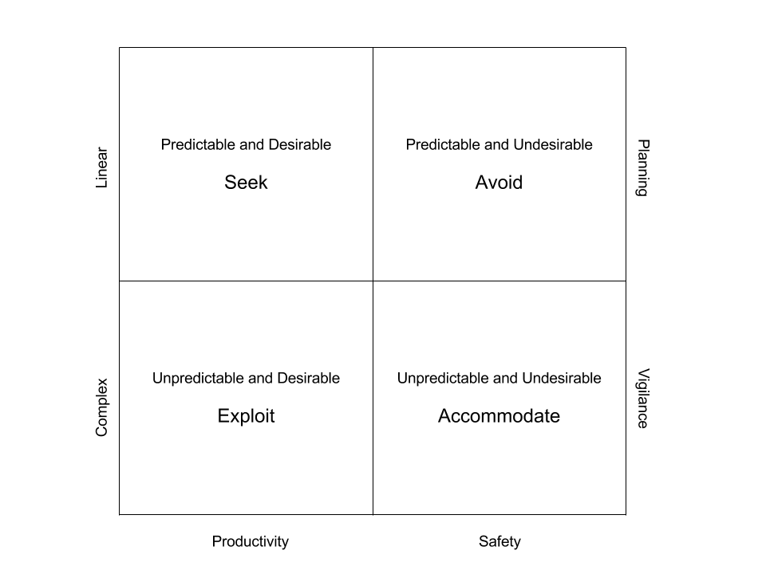
Figure 3: Management implications
Choice among the four management approaches suggested in figure 3 (seek, avoid, exploit, accommodate) could be guided by deciding whether or not the management aim under consideration involves system entities that are complex systems in their own right. If not, the direct planning approaches suggested in the top two quadrants may be most appropriate. If so, the more ‘fuzzy’ approach of vigilance shown in the bottom two quadrants may be more appropriate. In relation to avoiding adverse outcomes, Snowden (2006) refers to this as the creation of ‘safe to fail’ spaces. More recently, safety science scholars have advocated a shift from an ‘anticipatory’ approach to safety management in complex, safety critical domains, to one based on the building of resilience (Macrae, 2014). For the LOA domain, this supports the need to build redundant capacity into the system where critical safety and productivity aims are at stake. Furthermore, it supports the need to apply the STS principles of design simplicity and flexibility, along with the concomitant training and empowering of operational workers to ‘finish the design’ (Rasmussen, 1997).
On the face of it, led outdoor activity systems may not appear to be similar in nature to the kinds of systems that are typically discussed in the complex sociotechnical systems literature. Take, for example, a large military system (e.g. Jenkins et al., 2012) versus the three-day trek system described earlier. The former is vast, comprising multiple actors, organisations, and advanced technologies, and can remain connected whilst spanning entire continents. The latter is logistically simple and affords an experience of simple living for participants. It may be that these appearances of simplicity lead practitioners to reject the suggestion that the system of work within which logistical and experiential simplicity occurs, can itself be complex.
By looking beyond simplistic descriptions of led outdoor recreation, the case study presented in this article has provided evidence that LOA work systems do in fact exhibit the characteristics associated with ‘complex’ and ‘sociotechnical’ systems. Even in the most simplistic of led outdoor activities, the system and emergent behaviours are such that complexity is achieved.
This has significant implications, not only for safety in this domain, but also for other dimensions of work including productivity, program design, organisational design, work procedures, training and regulation. If the prevailing view of the system is linear and mechanistic, interventions to improve safety or productivity are likely to focus on system components, and are thus likely to be inappropriate and have little impact. Salmon et al (2014; 2016) report that traditionally, accident analysis in this domain has sought to identify root causes associated with components (e.g. instructors, equipment) and has typically recommended changes to those components as remedies. Initiatives to improve quality or productivity will focus on changing the characteristics of components or introducing new ones, with little consideration of the impacts on overall system functioning. In more conventional complex systems, these approaches to improving safety and efficiency are known to be ineffective (e.g. Dekker & Pruchnicki, 2014; Reason, 1997). Viewing led outdoor activity systems through a ‘simple, non-complex and non-sociotechnical’ lens engenders inappropriate approaches for improving them.
By contrast, a systems view of the led outdoor activity work domain will encourage analysts of accidents to be alert for causal factors arising from patterns of interactions between elements within and across system levels. Managers will be encouraged to seek productivity and safety improvements through changes to the relationships between system elements as well as in the elements themselves. Program designers will be more likely to explore alternative program designs and options within programs to achieve aims. Regulatory systems will be designed in ways that support the flexibility and adaptability that a complex system requires for optimal performance. By viewing LOA work systems through the same lenses as we do more traditional complex safety critical systems we will expand our theoretical toolkit, providing the opportunities to gather richer data, to exercise more explanatory power, and ultimately to better optimise led outdoor activity systems.
The LOA sector provides an important and growing service around the world. Recognition of the value of meaningful experiences outdoors grows as technological and environmental trajectories place greater stress on many people (e.g. Louv, 2008). The economic value of LOAs is increasingly being recognized (e.g. Marsden Jacob Associates, 2016). By neglecting contemporary thinking and practice in safety science, including the development of sociotechnical system models of accident causation, LOA research may not have appropriately supported this important sector. Further applications of systems thinking research are encouraged. Whilst these are important for the safety of LOAs (see implications for research section), applications in other areas are also encouraged. These include program design, training design, and regulatory system reform.
A project is currently underway in Australia to amalgamate separate state-based Adventure Activity Standards into a single, national set of standards (Outdoors Victoria, 2015a). It is hoped that this study may contribute to the growing application of STS approaches in the LOA domain in a way that supports reforms of safety regulation and management. A recognition by reformers of the complex, sociotechnical nature of the domain may be an important foundation for confidence in the further application of STS theory and methods.
As an exploratory case study there are some limitations to acknowledge. The findings of the present study are limited by its hypothetical nature. Analysis of the typical program studied here is sufficient to clearly identify that led outdoor activity programs do exhibit most or all of the established characteristics of complex, dynamic sociotechnical systems. Given the logistical simplicity of this example system, we argue that its characteristics discussed here will also be present in more complicated led outdoor activity work systems. However, the application of action research methods to system analyses of actual programs is likely to yield richer results including revealing how worker understanding of the system of work shapes program design and outcomes. In addition, other recent analyses also provide evidence in support of the notion that LOA are complex and sociotechnical in nature (e.g. Salmon et al., 2014; 2016).
Implications for research
Whilst the opportunities of acknowledging the complex sociotechnical nature of led outdoor activity systems have been discussed, there are some potential pitfalls. For example, it is worth noting a key concern underlying some criticisms of applications of systems thinking to the domain of led outdoor activities (Salmon, Williamson, Mitsopoulos-Rubens, Rudin-Brown, & Lenne, 2009). Here critics have expressed a fear that by attributing accident causation to factors other than the actions or omissions of leaders, those leaders may become more prone to abrogate their responsibilities for safety and want to blame ‘the system’ for their own failures. This concern has previously been raised in other domains. Dekker and Breakey (2016), for example, cite Sharpe’s (2003) observations about similar concerns in the domain of patient safety. They advocate an approach to worker accountability that takes place within a ‘Just Culture’ where errors and violations by workers are treated by the organisation in a manner designed to constructively address harms, needs and causes. At the same time, deeper, systemic issues are identified and addressed. Dekker and Breakey also tackle this issue, discussing how accountability is held regardless of whether a systems approach is taken or not as a result of aspects such as professionalism and personal involvement. They also describe 2nd victim syndrome, whereby those involved in adverse events can experience similar levels of trauma as the victims themselves. A systems approach neither removes accountability nor prevents accountability from being held by those involved in incidents.
Future research initiatives may benefit the led outdoor activities sector by examining how approaches like Dekker’s ‘Just Culture’ (Dekker & Breakey, 2016) might address concerns about abrogation of responsibility. Whilst systems theoretical approaches are supporting a growing body of research on safety, great potential also exists to apply systems thinking to the analysis of productivity in the LOA domain. Despite any concerns that may remain among LOA practitioners, the results of this study show that the continuing application of STS methods in this domain is both appropriate and necessary.
Are all work systems complex and sociotechnical in nature?
Given that the primary finding of this article was a confirmation that the apparently simplistic sys-tem of led outdoor activities is complex and sociotechnical in nature, it is worth touching briefly on the notion that this is true of every system involving humans interacting with human and non-human entities. Certainly such systems would qualify as sociotechnical in nature; however, the relevance of complexity is dependent specifically on the nature of the activity being undertaken, the role of complex system components (such as people) in the activity and the impact of unpredictability on system objectives.
Conclusion
This case study demonstrates that the system of work that supports even a logistically simple led outdoor activity program displays all of the hallmarks of so-called complex sociotechnical systems. The simplistic nature of the work system analysed supports the proposition that most or all led outdoor activity programs occur within complex, dynamic sociotechnical systems. The findings therefore suggest that, not only is a sociotechnical systems approach warranted in this domain, it is required should research achieve its aims of optimising safety and efficiency.
This recognition provides analysts and designers with a firm theoretical foundation, previously missing from accident analyses, work design and system development in this domain. The improved objectivity and analytic tools afforded by this foundation offer unprecedented opportunity to enhance the safety, performance and resilience of led outdoor activity programs.
It is hoped that the case study analysis presented acts as a call to arms for researchers in the area of led outdoor activities. In order to explore the benefits available from the application of systems thinking to the led outdoor activity domain, further research is required. A useful starting point would be to look at perceptions of the work system within the sector to build a picture of how it is understood by people in key roles such as regulators, program designers, managers and leaders. Studies examining how sociotechnical systems theory could be usefully applied to safety regulation, organisational structure, program design, staff training and achieving program aims could follow.
References
Brackenreg, M. (1999). Learning from our mistakes – before it’s too late. Australian Journal of Outdoor Education, 3(2), 27-33.
Brookes, A. (2011). Research update 2010: Outdoor education fatalities in Australia. Australian Journal of Outdoor Education, 15(1), 35-55.
Cherns, A. (1987). Principles of Sociotechnical Design Revisted. Human Relations, 40(3), 153-161. doi:10.1177/001872678704000303
Cilliers, P. (1998). Complexity and Postmodernism : Understanding Complex Systems. London: Routledge.
Clegg, C. W. (2000). Sociotechnical principles for system design. Applied Ergonomics, 31(5), 463-477. doi:http://dx.doi.org/10.1016/S0003-6870(00)00009-0
Crosby, S., & Benseman, J. (2003). Vivisecting the Tui: The Qualifications Framework and outdoor leadership development in New Zealand. Australian Journal of Outdoor Education, 7(2), 34-44.
Dallat, C., Salmon, P. M., & Goode, N. (2015). All about the Teacher, the Rain and the Backpack: The Lack of a Systems Approach to Risk Assessment in School Outdoor Education Programs. Procedia Manufacturing, 3, 1157-1164. doi:http://dx.doi.org/10.1016/j.promfg.2015.07.193
Davidson, G. (2007, 20-23 September 2007). Towards understanding the root causes of outdoor education incidents. Paper presented at the 15th National Outdoor Education Conference, Ballarat, Victoria.
Dekker, S., & Pruchnicki, S. (2014). Drifting into failure: theorising the dynamics of disaster incubation. Theoretical Issues in Ergonomics Science, 15(6), 534-544. doi:10.1080/1463922X.2013.856495
Dekker, S. W. A., & Breakey, H. (2016). ‘Just culture:’ Improving safety by achieving substantive, procedural and restorative justice. Safety Science, 85, 187-193. doi:http://dx.doi.org/10.1016/j.ssci.2016.01.018
Devonport, C. J., Coroner. (2010). Inquiry into the deaths of Antony McCLEAN, Natasha Aimee BRAY, Portia Caitlin McPHAIL, Huan (Tom) HSU, Anthony Walter MULDER, Floyd Mariano FERNANDES, Tara Rochelle GREGORY. Retrieved from Aukland District Court: http://outdoorcouncil.asn.au/doc/Coroners_Report_OPC.pdf
Eason, K. (2014). Afterword: The past, present and future of sociotechnical systems theory. Applied Ergonomics, 45(2, Part A), 213-220. doi:http://dx.doi.org/10.1016/j.apergo.2013.09.017
Goode, N., Finch, C. F., Cassell, E., Lenné, M. G., & Salmon, P. M. (2014). What would you like? Identifying the required characteristics of an industry-wide incident reporting and learning system for the led outdoor activity sector. Australian Journal of Outdoor Education, 17(2), 2-15.
Goode, N., Salmon, P. M., Lenné, M. G., & Finch, C. F. (2015). The UPLOADS Project: Development of an Australian National Incident Dataset for Led Outdoor Activities. Wilderness & Environmental Medicine, 26(4), 574-576. doi:http://dx.doi.org/10.1016/j.wem.2015.04.006
Goode, N., Salmon, P. M., Taylor, N. Z., Lenné, M. G., & Finch, C. F. (2016). Lost in translation: the validity of a systemic accident analysis method embedded in an incident reporting software tool. Theoretical Issues in Ergonomics Science, 17(5-6), 483-506. doi:10.1080/1463922X.2016.1154230
Hollnagel, E. (2012). FRAM, the Functional Resonance Analysis Method : Modelling Complex Socio-technical Systems. Farnham, Surrey, UK England: Ashgate.
Jenkins, D. P., Stanton, N. A., Salmon, P. M., & Walker, G. H. (2009). Cognitive Work Analysis : Coping with Complexity. Farnham, England: Ashgate.
Jenkins, D. P., Walker, G. H., Stanton, P. N. A., Salmon, P. P. M., Harris, P. D., & Salas, E. (2012). Command and Control: The Sociotechnical Perspective: Ashgate Publishing Limited.
Klein, L. (2014). What do we actually mean by ‘sociotechnical’? On values, boundaries and the problems of language. Applied Ergonomics, 45(2, Part A), 137-142. doi:http://dx.doi.org/10.1016/j.apergo.2013.03.027
Kurtz, C. F., & Snowden, D. J. (2003). The new dynamics of strategy: Sense-making in a complex and complicated world. IBM Systems Journal, 42(3), 462.
Leveson, N. (2004). A new accident model for engineering safer systems. Safety Science, 42(4), 237-270. doi:http://dx.doi.org/10.1016/S0925-7535(03)00047-X
Lichtenstein, B. B., & Plowman, D. A. (2009). The leadership of emergence: A complex systems leadership theory of emergence at successive organizational levels. The Leadership Quarterly, 20(4), 617-630. doi:http://dx.doi.org/10.1016/j.leaqua.2009.04.006
Louv, R. (2008). Last Child in the Woods: Saving Our Children From Nature-Deficit Disorder: Algonquin Books.
Macrae, C. (2014). Close Calls: Managing Risk and Resilience in Airline Flight Safety (1 ed.): Palgrave Macmillan UK.
Marsden Jacob Associates. (2016). Victoria’s nature-based outdoor economy: Key estimates and recommendations. Retrieved from http://outdoorsvictoria.org.au/wp-content/uploads/2016/03/Outdoor-Economics.pdf
Martin, B., Cashel, C., Wagstaff, M., & Breunig, M. (2006). Outdoor leadership: theory and practice. U.S.A.: Human Kinetics.
Meyer, D. (1979). The Management of Risk. Journal of Experiential Education, 2(2), 9-14.
Naikar, N. (2013). Work Domain Analysis: Concepts, Guidelines, and Cases: Taylor & Francis.
Outdoors Victoria. (2015a). Australian Adventure Activity Standards. Retrieved from http://australianaas.org.au/
Priest, S., & Gass, M. A. (2005). Effective Leadership in Adventure Programming: Human Kinetics.
Rasmussen, J. (1997). Risk management in a dynamic society: a modelling problem. Safety Science, 27(2–3), 183-213. doi:http://dx.doi.org/10.1016/S0925-7535(97)00052-0
Read, G. J., Salmon, P. M., Lenne, M. G., & Stanton, N. A. (2015). Designing sociotechnical systems with cognitive work analysis: putting theory back into practice. Ergonomics, 58(5), 822-851. doi:10.1080/00140139.2014.980335
Reason, J. T. (1997). Managing the risks of organizational accidents: Ashgate.
Salmon, P., Williamson, A., Lenné, M., Mitsopoulos-Rubens, E., & Rudin-Brown, C. M. (2010). Systems-based accident analysis in the led outdoor activity domain: application and evaluation of a risk management framework. Ergonomics, 53(8), 927-939. doi:10.1080/00140139.2010.489966
Salmon, P., Williamson, A., Mitsopoulos-Rubens, P., Rudin-Brown, C., & Lenne, M. (2009). The role of human factors in led outdoor activity accidents: literature review and exploratory analysis. In M. University Accident Research Centre (Ed.), (pp. 1-68). Australia: Monash University Accident Research Centre.
Salmon, P. M., Cornelissen, M., & Trotter, M. J. (2012). Systems-based accident analysis methods: A comparison of Accimap, HFACS, and STAMP. Safety Science, 50(4), 1158-1170. doi:http://dx.doi.org/10.1016/j.ssci.2011.11.009
Salmon, P. M., Goode, N., Lenne, M. G., Finch, C. F., & Cassell, E. (2014). Injury causation in the great outdoors: A systems analysis of led outdoor activity injury incidents. Accident Analysis & Prevention, 63, 111-120. doi:10.1016/j.aap.2013.10.019
Salmon, P. M., Goode, N., Taylor, N., Lenne, M. G., Dallat, C. E., & Finch, C. F. (2016). Rasmussen's legacy in the great outdoors: A new incident reporting and learning system for led outdoor activities. Appl Ergon. doi:10.1016/j.apergo.2015.07.017
Salmon, P. M., Williamson, A., Mitsopoulos-Rubens, P., Rudin-Brown, C., & Lenne, M. G. (2009). The role of human factors in led outdoor activity accidents: literature review and exploratory analysis. Retrieved from Australia: http://eprints.qut.edu.au/80789/
Sharpe, V. A. (2003). Promoting patient safety: an ethical basis for policy deliberation. Hastings Center Report, 33(5), S3-20 21p.
Skyttner, L. (2005). General Systems Theory: Problems, Perspectives, Practice: World Scientific.
Smith, H., & Penney, D. (2010). Effective, exemplary, extraordinary? Towards an understanding of extraordinary outdoor leadership. Australian Journal of Outdoor Education, 14(1), 23(27).
Snowden, D. (2006). Safe-Fail or Fail-Safe. Retrieved from http://cognitive-edge.com/blog/safe-fail-or-fail-safe/
Storr, J. (2005). A Critique of Effects-Based Thinking. RUSI Journal, 150(6), 32-35.
Toft, Y., Dell, G., Klockner, K., & Hutton, A. (2012). Models of Causation: Safety The Core Body of Knowledge for Generalist OHS Professionals. Tullamarine, VIC.: Safety Institute of Australia.
Trist, E. (1981). The evolution of socio-technical systems. Occasional paper, 2, 1981.
Trist, E. L., & Bamforth, K. W. (1951). Some Social and Psychological Consequences of the Longwall Method of Coal-Getting: An Examination of the Psychological Situation and Defences of a Work Group in Relation to the Social Structure and Technological Content of the Work System. Human Relations, 4(1), 3-38. doi:10.1177/001872675100400101
Trotter, M. J., Salmon, P. M., & Lenné, M. G. (2013). Improvisation in Safety Critical Situations: An Analysis of Improvisation Incidents in Led Outdoor Activities. Paper presented at the The 11th International Conference on Naturalistic Decision Making, Marseille, France.
Vicente, K. J. (1999). Cognitive work analysis : toward safe, productive, and healthy computer-based work. Mahwah, N.J.: Mahwah, N.J. : Lawrence Erlbaum Associates.
Vicente, K. J., & Christoffersen, K. (2006). The Walkerton E. coli outbreak: a test of Rasmussen's framework for risk management in a dynamic society. Theoretical Issues in Ergonomics Science, 7(2), 93-112. doi:10.1080/14639220500078153
von Bertalanffy, L. (1975). Perspectives on general system theory: scientific-philosophical studies: G. Braziller.
Walker, G. H., Stanton, N. A., Salmon, P. M., & Jenkins, D. P. (2008). A review of sociotechnical systems theory: a classic concept for new command and control paradigms. Theoretical Issues in Ergonomics Science, 9(6), 479-499. doi:10.1080/14639220701635470
White, P., Coroner. (2014). Inquest into the death of Kyle William Vassil. Retrieved from Melbourne: http://www.coronerscourt.vic.gov.au/resources/235cee6c-4ed6-4d07-b62c-c85097d669e3/kylewilliamvassil_066110.pdf
Williams, I. R. (2012). National Survey of Australian Outdoor Youth Programs. Retrieved from Melbourne, Victoria.

