Survey: Incident Prevention Strategy Evaluation

Background & Aim
Since 2008, the UPLOADS Research Team have been engaged in a major program of research that aims to tackle issues around incident causation in the outdoor activity sector in Australia. This has involved the development of an incident reporting system that is now used by a significant proportion of the sector across all states in Australia. Over the past year, many organisations have contributed their incident and participation data to the UPLOADS National Incident Dataset. This dataset is now the most comprehensive source of information available on incidents during outdoor activities in Australia.
An important question lies in how the sector can exploit this dataset moving forward. Accordingly, we recently conducted a series of workshops in Victoria and Queensland to identify, based on the dataset, strategies to reduce incidents during led outdoor activities. The attendees at the workshops included representatives from across the LOA system, including actors from the following: secondary schools; outdoor education providers; outdoor training organisations; outdoor sector peak bodies; work health and safety (WHS) regulator; and relevant government departments. The attendees were asked to identify strategies that could be implemented across the outdoor activity sector. Furthermore, they were encouraged to think about sets of strategies that could be implemented together with a system-wide approach rather than single strategies aimed at lower levels within the system (e.g. improve training of Activity Leaders or purchase new equipment). The strategies identified were based on the issues identified in the UPLOADS National Incident Dataset Report: 1st June 2014 to 31st May 2015, which included incidents resulting in injuries, illnesses and near misses.
A key requirement is that the identified strategies are analysed by members of the sector. The aim of this survey is therefore to provide the sector with the opportunity to evaluate the strategies that were identified during these workshops. The strategies addressed the following issues:
- Ensuring that activity programs are appropriate for Activity Participants’ skill levels;
- Improving the physical literacy of Activity Participants;
- Prevention of camp craft injuries;
- Improving the capacity of Activity Centres for anticipating and managing Activity Participants’ pre-existing injuries and physical disabilities;
- Improving the capacity of Activity Centres for anticipating and managing Activity Participants’ illnesses, medical emergencies and mental illness;
- Improving the capacity of Activity Leaders to assess changes in environmental conditions and adapt programs accordingly; and
- More clarity in defining the roles and responsibilities of parents and teachers when supervising activities

In the following sections, you will be asked to evaluate the strategies that were identified during the workshops to address each of these issues. In particular, we want to gain input from those within the outdoor activity sector to ensure that strategies recommended are practical, reasonable and appropriate for this sector.
To conduct the evaluation, you will be provided with the following information for each issue:
- How the issue relates to the UPLOADS data;
- A description of the set of strategies identified to address the issue;
- A diagram depicting the strategies, how they relate to each other, and the actors primarily involved in implementing them;
- A rating scale to evaluate the strategies against a set of pre-determined evaluation criteria; and
- A comment box to give you the opportunity to provide additional comments and feedback about the strategies.

How to read the diagrams
The diagrams represents a summary of the strategies and the relationships that were identified between the different strategies. The boxes include information detailing the strategies and the organisations or individuals that would implement them. At the top of the diagram are strategies that would be implemented by government departments. At the next level down by Regulatory bodies and associations, followed by: Local area government, schools and parents, and Activity Centre; Supervisors and (field) managers; and leaders, participants and other actors in the activity environment. The bottom level concerns strategies related to equipment, environment and meteorological conditions. The lines linking the boxes represent relationships between the strategies and involved actors. These relationships describe how strategies are supported by other strategies. For example, a line between a strategy involving Schools and a strategy involving the Department of Education shows that both strategies are supporting each other to achieve a common goal (e.g. improving the physical literacy of Activity Participants).

Thank you for your participation – your input is greatly appreciated!

Survey: Incident Prevention Strategy Evaluation

- What is your age? years

- What is your gender?
Male
Female
Other

- Please select the category that best describes how your organisation fits within the organised outdoor activity sector:
Primary school
Secondary school
Outdoor education/recreation provider
Outdoor training organisation (e.g. RTO, TAFE, University)
Outdoor professional/peak body
Workplace health and safety regulator
Government agency
Other (please specify)

- What is your occupation and job title?

- Do you lead outdoor activities as part of your current role?

Yes No

- Does your role involve the development of interventions designed to prevent incidents?

Yes No

- In total, for how many years have you worked within or been involved in the outdoor activity sector?
years

- Please read the section below, view the diagram on the following page and answer the evaluation questions.

Issue 1: Ensuring that led outdoor activity programs are appropriate for Activity Participants’ skill levels

Strategies were developed to improve the match between the skills required for the outdoor activity and the skills of Activity Participants. This issue was identified in response to two of the most frequently identified contributing factors in the UPLOADS data: “Activity Participant: Experience and Competence” and “Activity Participant: Communication and Following Instructions”. These factors were identified in 85 and 55 injury-causing incidents out of 363, respectively, and were highly interconnected to other factors. Based on this data and their experience in the outdoors, the workshop participants argued that many injuries occurred because the design of the activity program did not adequately take into account Activity Participants’ level of experience in the outdoors, and Activity Participants were ill prepared for the program (in terms of both physical literacy and equipment).

Figure 1 shows the strategies that were identified to address this issue. The strategies address two central goals: improving communication between parents, schools and the Activity Centre regarding participants’ capabilities; and implementing systems to increase the flexibility of program design. For example, workshop participants suggested that the Department of Education should provide more resources and time to enable schools to prepare participants for programs and gather information about their skills and abilities, which in turn, would enable schools to collect and provide information to Activity Centres on participants’ competence, which Activity Centres would then feed down into the development of programs. Workshop participants also suggested that Activity Leaders should be able to dynamically adapt programs to suit the skills of the group. They suggested that training on how to identify the skills of participants and adapt activity programs to suit different skill levels, as well as specific policies enabling flexibility in program delivery, would be needed to support Activity Leaders performing this function.

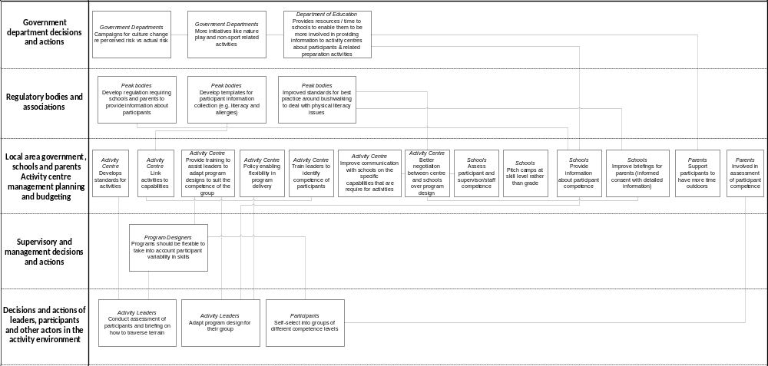
Figure 1. The Strategies and the relationships between them to ensure the program is appropriate for Activity Participants’ skill level.

Question. Please evaluate the strategies that were identified to ensure that the program is appropriate for participants’ skill level:

 | Strongly disagree |  |  | Neutral |  |  | Strongly agree | Unsure
These strategies address an important issue for the sector. | 1 | 2 | 3 | 4 | 5 | 6 | 7
These strategies are a reasonable measure to reduce risk, which will not negatively impact on the potential benefits of outdoor activities. | 1 | 2 | 3 | 4 | 5 | 6 | 7
These strategies apply to all states and territories in Australia. | 1 | 2 | 3 | 4 | 5 | 6 | 7
These strategies apply to all sub-groups within the sector (e.g. outdoor education, youth at risk, adventure tourism). | 1 | 2 | 3 | 4 | 5 | 6 | 7
The benefits of implementing these strategies are likely to outweigh the costs to the sector. | 1 | 2 | 3 | 4 | 5 | 6 | 7
These strategies have the potential to fundamentally reduce incidents during led outdoor activities. | 1 | 2 | 3 | 4 | 5 | 6 | 7
These strategies may have negative, unintended consequences for safety. | 1 | 2 | 3 | 4 | 5 | 6 | 7
These strategies are practical and feasible to implement. | 1 | 2 | 3 | 4 | 5 | 6 | 7

If you have any additional comments, please mention these in the text box below:
(e.g. comments on the strategies or in relation to previous questions)

- Please read the section below, view the diagram on the following page and answer the evaluation questions.

Issue 2: Improving the physical literacy of Activity Participants

Strategies were developed to improve the physical literacy of Activity Participants. Strategies related to the first goals were developed in response to three of the most frequently identified contributing factors in the UPLOADS data: “Activity Participant: Experience and Competence” (85 out of 363 injuries, 12 out of 68); “Activity Participant: Judgement and Decision-Making” (118 out of 363 injuries and 12 out of 68 near misses); “Activity Participant: Communication and Following Instructions” (55 out of 363 injuries); and “Activity Participant: Mental and Physical Condition” (61 out of 363 injuries and 9 out of 68 near misses). Drawing on their experience in the outdoors, workshop participants reported that most Activity Participants have had minimal exposure to the outdoors prior to the activity. In addition, workshop participants suggested that modern society operates within a “cotton wool” culture where grazing your knees during outdoor activities is being perceived as “bad”. This was thought to form a real issue for Outdoor Educators, which needs to be addressed.

Figure 2 shows the strategies that were developed to improve the physical literacy. Workshop participants reported that Government and Peak Bodies would need to lobby to change societal perspectives in relation to outdoors. Especially the “cotton wool” culture needs to be addressed and through education beliefs need to be changed to “it’s ok to have grazed knees”. This culture change needs to be pushed to get children outdoors, which will result in Activity Participants that are more familiar with the outdoors. To support this, Government, Peak Bodies, Activity Providers, Schools and Research Institutions would need to improve the dissemination of information on the benefits of Outdoor Education. The Department of Education would need to: adjust the curriculum to ensure more focus on outdoor education; embed programs into schools early (e.g. nature play); and implement outdoor education guidelines and education of school staff. To support this, Peak Bodies would need to lobby the Government to fund and develop educational programs to promote physical literacy, and work together with schools to stimulate parents and children to get outdoors more. Schools would need to embed outdoor education programs (e.g. nature play) into curriculum early on, and join forces with parents to build physical resilience in children. To further support this, Activity Centres would need to communicate with schools and parents about the organisational aims and learning goals to address the importance of ‘getting out’. In addition, Parents would need to further support this by introducing more outdoor recreation early on in their child(ren)’s life. Workshop participants reported that a lack of physical literacy went hand in hand with lack of knowledge around appropriate equipment (e.g. clothing and shoes). Schools and Activity Centres therefore also need to educate parents on appropriate equipment prior to activities. This would need to be supported by the Government providing funding to increase availability of appropriate equipment to Schools and Parents.

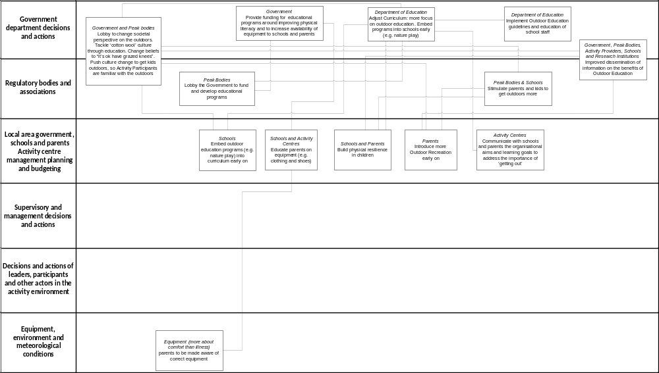
Figure 2. Strategies and the relationships between them to improve the physical literacy of Activity Participants

Question. Please choose the response below that best reflects your opinions with regard to the set of strategies related to improving the physical literacy of Activity Participants:

 | Strongly disagree |  |  | Neutral |  |  | Strongly agree | Unsure
These strategies address an important issue for the sector. | 1 | 2 | 3 | 4 | 5 | 6 | 7
These strategies are a reasonable measure to reduce risk, which will not negatively impact on the potential benefits of outdoor activities. | 1 | 2 | 3 | 4 | 5 | 6 | 7
These strategies apply to all states and territories in Australia. | 1 | 2 | 3 | 4 | 5 | 6 | 7
These strategies apply to all sub-groups within the sector (e.g. outdoor education, youth at risk, adventure tourism). | 1 | 2 | 3 | 4 | 5 | 6 | 7
The benefits of implementing these strategies are likely to outweigh the costs to the sector. | 1 | 2 | 3 | 4 | 5 | 6 | 7
These strategies have the potential to fundamentally reduce incidents during led outdoor activities. | 1 | 2 | 3 | 4 | 5 | 6 | 7
These strategies may have negative, unintended consequences for safety. | 1 | 2 | 3 | 4 | 5 | 6 | 7
These strategies are practical and feasible to implement. | 1 | 2 | 3 | 4 | 5 | 6 | 7

If you have any additional comments, please mention these in the text box below:
(e.g. comments on the strategies or in relation to previous questions)

- Please read the section below, view the diagram on the following page and answer the evaluation questions.

Issue 3: Prevention of camp craft injuries

Strategies were developed to reduce the number of camp craft injuries. In the UPLOADS data, camp craft activities primarily relate to cooking and campfires. This issue was identified in response to the finding that camp craft activities had one of the highest rates of injury and near miss reports in the UPLOADS data. The contributing factors most frequently associated with these types of incidents were: “Activity Participant: compliance with procedures, violations & unsafe acts” (26 out of 363 injuries and 8 out of 68 near misses); “Activity Participant: Communication & following instructions” (55 out of 363 injuries); “Activity Equipment and Resources: Equipment, clothing and Personal Protective Equipment” (120 out of 363 injuries); “Activity Leader: Supervision & leadership of activity” (26 out of 363 injuries and 9 out of 68 near misses); and “Activity Leader: Compliance with procedures, violations & unsafe acts” (7 out of 68 near misses). Drawing on their experience in the outdoors, workshop participants identified the following additional factors contributing to these incidents: 1) cooking is often not treated as a separate activity (and therefore not risk assessed); 2) cooking is typically perceived as time off for the leaders and teachers; 3) cooking and nutrition are not well integrated into the school curriculum; and 4) the Adventure Activity Standards (AAS) do not provide guidance on camp craft activities.

Figure 3 shows the strategies that were identified to address this issue. There were two central strategies: 1) Peak Bodies to develop an AAS for camp craft which includes supervision requirements and ratios around camp craft, and 2) Activity Centres to ensure availability, maintenance and safe use of cooking and other camp craft equipment.

The first central strategy is linked to many other strategies on several levels, all supporting the central strategy. For example, for this central strategy to be effective Peak Bodies would also need to: provide training for schools; help members to implement AAS standards; and ensure University and TAFE courses for Activity Leaders include curriculum design around ‘free time’. To support this, the Department of Education would need to develop National standards for TAFE and university outdoor education and recreation courses (e.g. TAFE Certificate IV to include food handling for camps), and merge their camp craft activities standards with AAS standards. Further, Activity Design would need to provide clarity around role expectations and rules for camp craft activities, and ensure that Activity Leaders do not have additional responsibilities during cooking activities. In addition, Activity Leaders would need to improve briefings and supervision around camp craft.

For the second central strategy to be effective, activity centres would need to: purchase equipment to improve safety of camp craft activities; train staff how to maintain and use cooking and other camp craft equipment including a routine assessment of skills; improve communication with parents about a child’s previous experience with camp craft activities; and ensure field managers check the serviceability of cooking equipment. In addition, the Department of Education would need to include cooking and nutrition in primary and secondary curriculum to build capacity in experience, and schools would need to provide pre-trip training for students on cooking.

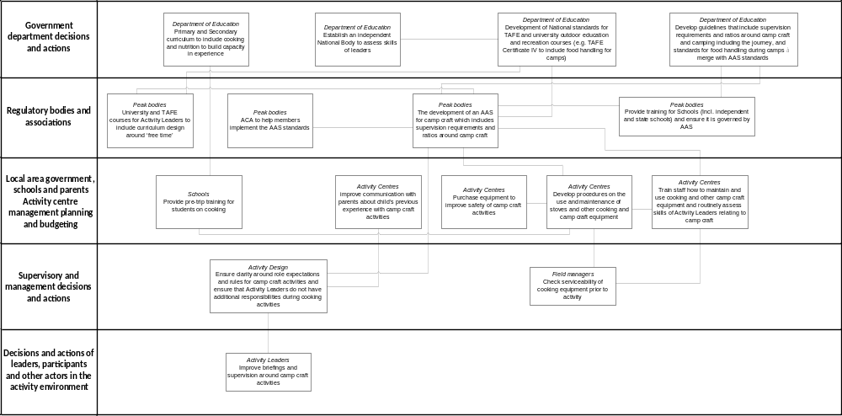
Figure 3. Strategies and the relationships between them to prevent camp craft injuries.

Question. Please choose the response below that best reflects your opinions with regard to the set of strategies related to prevention of camp craft injuries:

 | Strongly disagree |  |  | Neutral |  |  | Strongly agree | Unsure
These strategies address an important issue for the sector. | 1 | 2 | 3 | 4 | 5 | 6 | 7
These strategies are a reasonable measure to reduce risk, which will not negatively impact on the potential benefits of outdoor activities. | 1 | 2 | 3 | 4 | 5 | 6 | 7
These strategies apply to all states and territories in Australia. | 1 | 2 | 3 | 4 | 5 | 6 | 7
These strategies apply to all sub-groups within the sector (e.g. outdoor education, youth at risk, adventure tourism). | 1 | 2 | 3 | 4 | 5 | 6 | 7
The benefits of implementing these strategies are likely to outweigh the costs to the sector. | 1 | 2 | 3 | 4 | 5 | 6 | 7
These strategies have the potential to fundamentally reduce incidents during led outdoor activities. | 1 | 2 | 3 | 4 | 5 | 6 | 7
These strategies may have negative, unintended consequences for safety. | 1 | 2 | 3 | 4 | 5 | 6 | 7
These strategies are practical and feasible to implement. | 1 | 2 | 3 | 4 | 5 | 6 | 7

If you have any additional comments, please mention these in the text box below:
(e.g. comments on the strategies or in relation to previous questions)

- Please read the section below, view the diagram on the following page and answer the evaluation questions.

Issue 4: Improving the capacity of Activity Centres for managing pre-existing injuries and physical disabilities.

Strategies were developed to improve Activity Centres’ capacity for managing pre-existing injuries and physical disabilities. This was in response to a frequently identified contributing factor in the UPLOADS data: “Activity Participant: mental and physical condition”. This factor was identified in 61 out of 363 injuries. Drawing on their experience in the outdoors, workshop participants identified the following additional factors contributing to these incidents: 1) poor reporting on pre-existing injuries; 2) Activity Leaders’ competencies in dealing with pre-existing injuries; and 3) poor communication between Activity Centre, School, Activity Participants and Parents and Carers.

Figure 4 shows the strategies that were identified to address this issue. There were two central strategies: 1) Activity Centres to lead improved communication between parents, teachers, and the activity centre around health and pre-existing injuries; and 2) Activity leaders to ensure in-field program flexibility enabling participants to self-regulate their participation to suit their ability level.

To support the first central strategy, Activity Centres would also need to: reinforce and facilitate communication between participants, leaders and organisation around incident reporting; and ensure their website provides information on each activity detailing what pre-existing injuries need to be reported. Parents should visit the website prior to activities to ensure they know what activities will be happening and what needs to be reported. In addition, the Department of Education would need to ensure Curriculum Activity Risk Assessment Guidelines provide information about types of pre-existing injuries that should be reported.

To support the second central strategy, Peak Bodies would need to implement Activity Leader certification and training in relation to pre-existing injuries and disabilities. Activity Centres would need to: provide Activity Leader education including understanding and identifying complexities of physical health issues; and tackle the current perceived issue of lack of expertise of casual staff and freelancers by ensuring they have appropriate qualifications. Management would need to regularly assess performance (i.e. strengths and weaknesses) in order to guide additional training and ensure Activity Design includes mentor programs for Activity Leaders. In addition, Activity Leaders and Field Managers would need to be familiar with the specific activity environment so the route can be tailored to participants’ ability level.

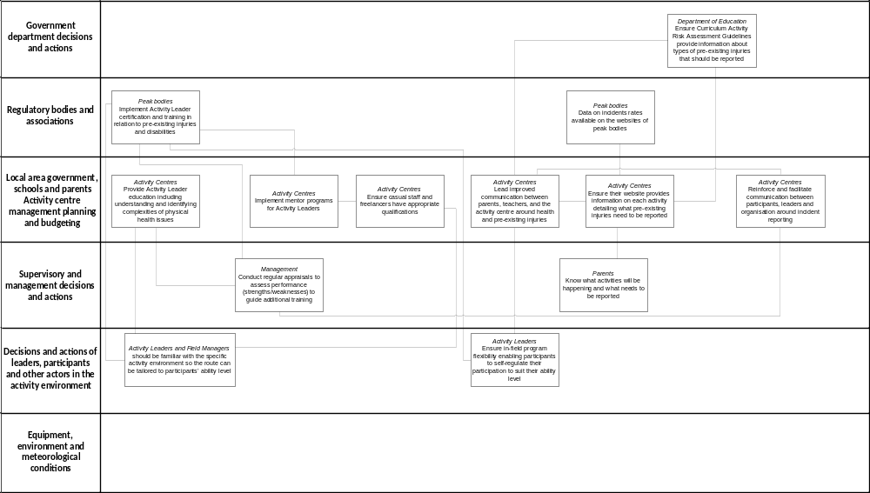
Figure 4. Strategies and the relationships between them to improve the capacity of Activity Centres for managing pre-existing injuries and physical disabilities.

Question. Please choose the response below that best reflects your opinions with regard to the set of strategies related to improving Activity Centres’ capacity for managing pre-existing injuries and physical disabilities, and improving participants’ reporting of pre-existing injuries:

 | Strongly disagree |  |  | Neutral |  |  | Strongly agree | Unsure
These strategies address an important issue for the sector. | 1 | 2 | 3 | 4 | 5 | 6 | 7
These strategies are a reasonable measure to reduce risk, which will not negatively impact on the potential benefits of outdoor activities. | 1 | 2 | 3 | 4 | 5 | 6 | 7
These strategies apply to all states and territories in Australia. | 1 | 2 | 3 | 4 | 5 | 6 | 7
These strategies apply to all sub-groups within the sector (e.g. outdoor education, youth at risk, adventure tourism). | 1 | 2 | 3 | 4 | 5 | 6 | 7
The benefits of implementing these strategies are likely to outweigh the costs to the sector. | 1 | 2 | 3 | 4 | 5 | 6 | 7
These strategies have the potential to fundamentally reduce incidents during led outdoor activities. | 1 | 2 | 3 | 4 | 5 | 6 | 7
These strategies may have negative, unintended consequences for safety. | 1 | 2 | 3 | 4 | 5 | 6 | 7
These strategies are practical and feasible to implement. | 1 | 2 | 3 | 4 | 5 | 6 | 7

If you have any additional comments, please mention these in the text box below:
(e.g. comments on the strategies or in relation to previous questions)

- Please read the section below, view the diagram on the following page and answer the evaluation questions.

Issue 5: Improving the capacity of Activity Centres for managing physical and mental illnesses, and medical emergencies

Strategies were developed to improve Activity Centres’ capacity for managing illnesses, medical emergencies and mental illness. This issue was identified in response to three of the most frequently identified contributing factors in the UPLOADS data: “Activity Participant: Mental and Physical Condition” (59 out of 86 illnesses), “Activity Equipment and Resources: Documentation” (11 out of 86 illnesses) and “Parents & Carers: Communication” (11 out of 86 illnesses). In eleven incidents (12%), poor documentation regarding participants pre-existing illnesses was directly linked to a lack of communication from parents and carers.

Figure 5 shows the strategies that were identified to address this issue. The workshop groups perceived that this issue is highly complex and sensitive, which is reflected in the large number of countermeasures (and relationships) that were identified to address this issue. The countermeasures address four inter-dependent goals: 1) standardising the collection of information on participants’ physical and mental health; 2) improving compliance with reporting of information; 3) designing programs to accommodate participants with physical and mental health issues; and 4) improving leaders’ competencies to deal with health issues in the field.

To address the first goal, workshop participants suggested that: the Department of Education and Independent Schools Networks would need to develop guidelines around the collection of medical data and the disclosure of information from parents; Peak bodies would need to engage members in developing standards on the specific medical information required in LOA activities; and Schools would need to implement standardised forms for collection of long- and short- term medical data. These countermeasures were linked together to illustrate that they are dependent on each other.

To address the second goal, workshop participants suggested that Peak bodies need to provide more clarity for Activity Centres on privacy laws and dealing with medical information, so that Activity Centres can better communicate with parents around the need to report medical information. It was also suggested that Schools could provide medical forms to parents in multiple languages.
To address the third goal, workshop participants suggested that Peak bodies should engage medical professional to provide information sessions on illnesses to Activity Centres, and develop standards for collecting the specific medical information required for activities. In turn, this information should feed into Program Design, which should also provide sufficient resources to cope with participants with mental health issues and deal with emergency situations relating to mental health issues.

To address the fourth goal, a range of training needs were identified, including mental health training, training on the identification and management of illnesses and medication and scenario-based training for dealing with emergency situations.

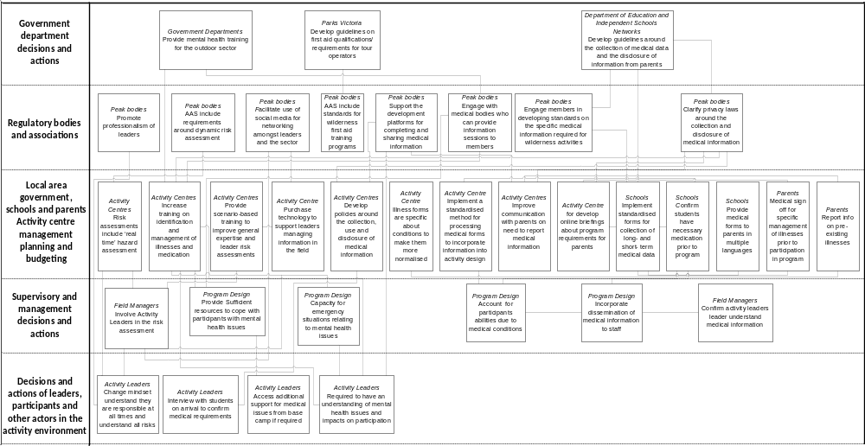
Figure 5. Strategies and the relationships between them to improve the capacity of Activity Centres for managing physical and mental illnesses, and medical emergencies.
Question. Please choose the response below that best reflects your opinions with regard to the set of strategies related to improving Activity Centres’ capacity for anticipating and managing illnesses, medical emergencies and mental illness:

 | Strongly disagree |  |  | Neutral |  |  | Strongly agree | Unsure
These strategies address an important issue for the sector. | 1 | 2 | 3 | 4 | 5 | 6 | 7
These strategies are a reasonable measure to reduce risk, which will not negatively impact on the potential benefits of outdoor activities. | 1 | 2 | 3 | 4 | 5 | 6 | 7
These strategies apply to all states and territories in Australia. | 1 | 2 | 3 | 4 | 5 | 6 | 7
These strategies apply to all sub-groups within the sector (e.g. outdoor education, youth at risk, adventure tourism). | 1 | 2 | 3 | 4 | 5 | 6 | 7
The benefits of implementing these strategies are likely to outweigh the costs to the sector. | 1 | 2 | 3 | 4 | 5 | 6 | 7
These strategies have the potential to fundamentally reduce incidents during led outdoor activities. | 1 | 2 | 3 | 4 | 5 | 6 | 7
These strategies may have negative, unintended consequences for safety. | 1 | 2 | 3 | 4 | 5 | 6 | 7
These strategies are practical and feasible to implement. | 1 | 2 | 3 | 4 | 5 | 6 | 7

If you have any additional comments, please mention these in the text box below:
(e.g. comments on the strategies or in relation to previous questions)

- Please read the section below, view the diagram on the following page and answer the evaluation questions.

Issue 6: Improving the capacity of Activity Leaders to assess changes in environmental and other conditions and adapt programs accordingly.

Strategies were developed to improve the capacity of Activity Leaders to assess changes in environmental conditions and adapt programs accordingly. This was in response to and identified higher level contributing factor in the UPLOADS data:
- “Higher Level Management: Training and Evaluation of Staff” (9 out of 363 injuries);
- “Supervisor/Field Manager: Activity or Program Design” (16 out of 363 injuries, 2 out of 86 illnesses and 5 out of 68 near misses were related to program design not being appropriate for the day);
- “Activity Leader: Judgement and Decision-making” (6 out of 363 injuries and 5 out of 68 near misses were related to failing to pick up on changing conditions and/or to adjust accordingly);
- “Activity Leader: Situation awareness” (4 out of 363 injuries and 4 out of 68 near misses were related to not being aware of changing conditions).

Workshop participants also discussed the commercial reality of relying on Activity Leaders with minimal training rather than more extensive Vocational Educational Training. In addition, it was reported that it was often unclear for Activity Leaders in terms of what is meant by dynamic risk assessment and that Activity Leaders need to be empowered to conduct dynamic risk assessments in the field.

Figure 6 shows the strategies that were developed to address this issue. The central strategy was “Supervisors or field managers to provide training to Activity Leaders in dynamic risk assessment: online and practical on the job delivery”. Workshop participants reported that Activity Leader training around identification and management of changing environments is needed. This would need to be achieved through ongoing training, professional development and peer mentoring. Activity Centres would need to develop policy around training in relation to dynamic risk assessment that also includes specific training requirements for casual staff. To support this Government, Peak Bodies, TAFEs and Universities would need to professionalise career pathways and create an environment to sustain careers in the Led Outdoor Activity (LOA) sector, for example by articulating skills, roles and career paths. Peak bodies would need to develop benchmarks to push appropriate dynamic risk assessment practice, and provide opportunities for the industry to talk about dynamic risk assessment.

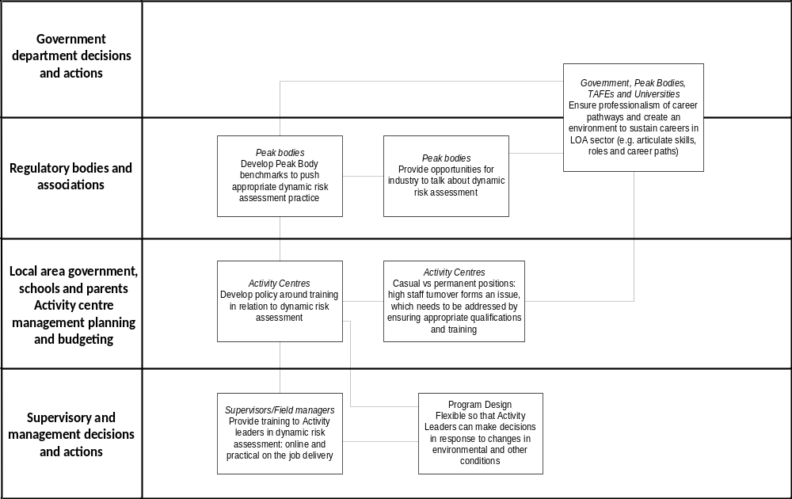
Figure 6. Strategies and the relationships between them to improve Activity Leaders’ capacity to assess changes in environmental conditions and adapt programs accordingly.

Question. Please choose the response below that best reflects your opinions with regard to the set of strategies related to improving Activity Leaders’ capacity to assess changes in environmental conditions and adapt programs accordingly:

 | Strongly disagree |  |  | Neutral |  |  | Strongly agree | Unsure
These strategies address an important issue for the sector. | 1 | 2 | 3 | 4 | 5 | 6 | 7
These strategies are a reasonable measure to reduce risk, which will not negatively impact on the potential benefits of outdoor activities. | 1 | 2 | 3 | 4 | 5 | 6 | 7
These strategies apply to all states and territories in Australia. | 1 | 2 | 3 | 4 | 5 | 6 | 7
These strategies apply to all sub-groups within the sector (e.g. outdoor education, youth at risk, adventure tourism). | 1 | 2 | 3 | 4 | 5 | 6 | 7
The benefits of implementing these strategies are likely to outweigh the costs to the sector. | 1 | 2 | 3 | 4 | 5 | 6 | 7
These strategies have the potential to fundamentally reduce incidents during led outdoor activities. | 1 | 2 | 3 | 4 | 5 | 6 | 7
These strategies may have negative, unintended consequences for safety. | 1 | 2 | 3 | 4 | 5 | 6 | 7
These strategies are practical and feasible to implement. | 1 | 2 | 3 | 4 | 5 | 6 | 7

If you have any additional comments, please mention these in the text box below:
(e.g. comments on the strategies or in relation to previous questions)

- Please read the section below, view the diagram on the following page and answer the evaluation questions.

Issue 7: More clarity in defining the roles and responsibilities of parents and teachers when supervising activities

Strategies were developed to provide more clarity around the roles and responsibilities of parents and teachers. This issue was identified in response to the factors relating to “Other people in the activity group” in the UPLOADS data:
- “Judgement and decision-making” (2 out of 68 near miss and 1 out of 363 injuries)
- “Supervision of activity” (2 out of 363 injuries, 1 out 68 near misses)
- “Experience, qualifications and competence” (2 out of 68 near misses)
- “Compliance with procedures, violations and unsafe acts” (1 out of 363 injuries)

The group discussions focussed on how parents and teachers are expected to play an essential supervisory role during programs, yet they often have little previous experience of programs or training for the role. These issues were also evident in the injury data. Drawing on their experience in the outdoors, workshop participants argued that many issues relating to supervision occurred because of a mismatch between the expectations of the Activity Centre regarding the role of supervising teachers and parents, and their perceptions and expectations.

Figure 7 shows the strategies that were identified to address this issue. Workshop participants suggested that the AAS would need to be modified to include a requirement for an induction for teachers and parents who will take on a supervisory role and provide guidance on the skills needed to supervise particular activities. This was suggested to ensure that parents and teachers assisting have the appropriate skills sets. These strategies were then linked to requirements for the Activity Centre, including the development of policies defining the roles and responsibilities for parents and teachers in a supervisory role, defining the skills required to supervise the specific programs run by the Centre, and providing an induction prior to the program which includes an assessment component.

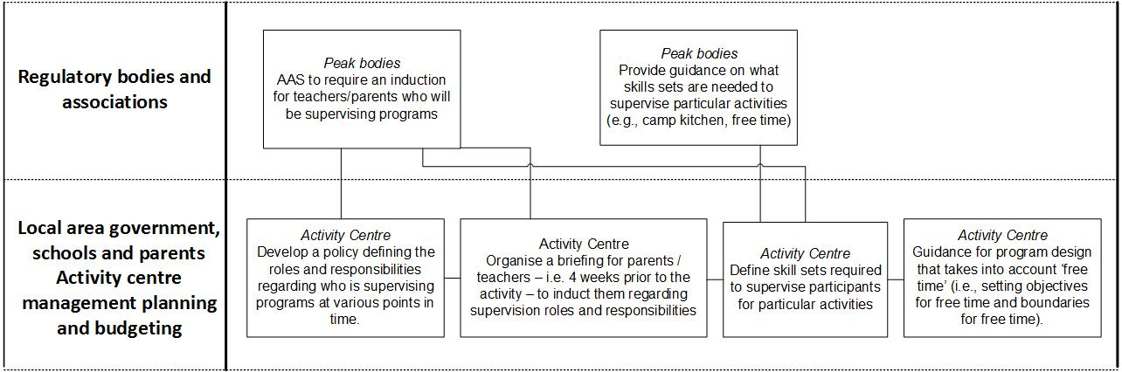
Figure 7. Strategies and the relationships between them to address the need for more clearly defined roles and responsibilities for parents and teachers when supervising activities.

Question. Please choose the response below that best reflects your opinions with regard to the set of strategies related to improved clarity around the role and responsibilities of parents and teachers when supervising activities:

 | Strongly disagree |  |  | Neutral |  |  | Strongly agree | Unsure
These strategies address an important issue for the sector. | 1 | 2 | 3 | 4 | 5 | 6 | 7
These strategies are a reasonable measure to reduce risk, which will not negatively impact on the potential benefits of outdoor activities. | 1 | 2 | 3 | 4 | 5 | 6 | 7
These strategies apply to all states and territories in Australia. | 1 | 2 | 3 | 4 | 5 | 6 | 7
These strategies apply to all sub-groups within the sector (e.g. outdoor education, youth at risk, adventure tourism). | 1 | 2 | 3 | 4 | 5 | 6 | 7
The benefits of implementing these strategies are likely to outweigh the costs to the sector. | 1 | 2 | 3 | 4 | 5 | 6 | 7
These strategies have the potential to fundamentally reduce incidents during led outdoor activities. | 1 | 2 | 3 | 4 | 5 | 6 | 7
These strategies may have negative, unintended consequences for safety. | 1 | 2 | 3 | 4 | 5 | 6 | 7
These strategies are practical and feasible to implement. | 1 | 2 | 3 | 4 | 5 | 6 | 7
If you have any additional comments, please mention these in the text box below:
(e.g. comments on the strategies or in relation to previous questions)

- End -

Thank you for your participation!

